GRAVITATIONAL TELECOMMUNICATION
by the DYNAMIC GRAVITY

Author: Dezso SARKADI

Updated: July of 2010

E-mail: dsarkadi@gmail.hu

1. Gravitational Transmitter and Receiver

Here is the detailed information about the dynamic gravity phenomenon explored in Hungary:

http://www.scribd.com/doc/15939620/Gravity-Experiment-with-Physical-Pendulum

As an example for the utilization of the dynamic gravity here is a simple demonstration apparatus for the gravitational communication. This gravitational transmitter-receiver arrangement has been successfully tested in the practice:

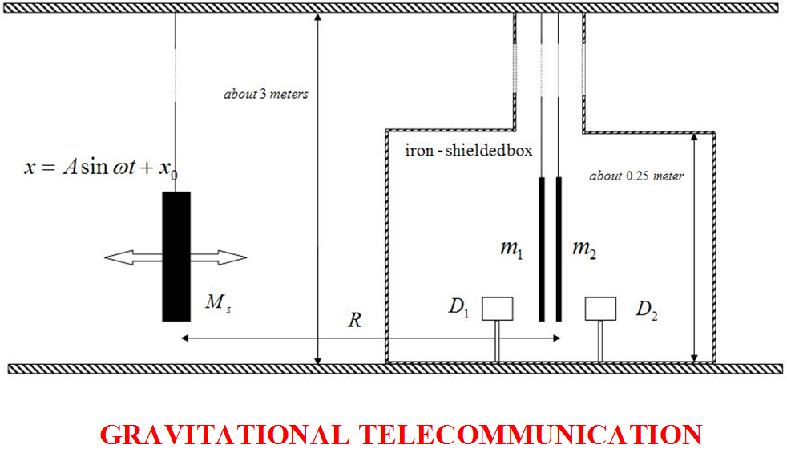

GRAVITATIONAL TRANSMITTER-RECEIVER EXPLORED IN HUNGARY

The gravitation signal detector is realized by two plan parallel ceramic tiles hanged to the ceiling with fishing lines about 3 meter longs. The tiles form a simple coupled pendulum with narrow resonance curve avoiding any caption of the environmental noise. The mass of the tiles is about 150-150 g. with dimensions 120 x 120 x 5 mm. The gap between the tiles is about 5 mm. The weak mechanical coupling between the tiles is realized by the air gap inside them. D1 and D2 are optical displacement detectors without any mechanical contacts with the tiles. The signals of the detectors are processed by a personal computer working in real-time regime. The typical amplitude of the ceramic tiles is about 20 micron in normal ground state.
The gravitational transmitter is a simple pendulum with the same frequency of the receiver coupled pendulum. The transmitter mass M_{s} is about 0.25 kg made of lead. The distance between the transmitter and receiver is about R = 5 meters. After a little pushing the transmitter mass the receiver gives a disturbance signal to the computer. In case of resonance the amplitude of the tiles rises up to 100 – 150 microns.
The appropriate shielding of the gravitational receiver is very important. The optimal condition of the successful experiment is a poor vibration and gravity noise environment.

2. Additional Dynamic Gravity Effects Experienced
Big surprise, the new gravity detector is sensitive not only for moving masses, but for variable intensity of light and heat as well. Especially it is sensitive for grinding machine is turned on and off, or mobile telephone calls, reception as well. This simple gravity detector can detect a wind storm even from distance of 50-100 km with its big swinging.
The reason of this behavior of the gravity detector is the dynamic gravity characteristic its sensitivity. It means that the new gravity detector certainly sensitive for all energy density changes of its surrounding space caused by any kinds of time-dependent energy sources even from long distances, too.
The background noise of the gravity detector is rather highest by day than at night. The simple reason of this fact is the strong dynamic gravity effect of the changing sunshine intensity outside of the laboratory. It is therefore absolutely necessary the greatly increasing the selectivity of the gravity detector to any future applications in the telecommunication fields.
Foreseeable that serious further improvement is needed if anybody wants to utilize the newly discovered phenomenon of the dynamic gravitation. That is why I am urgently looking for sponsors, investors to continue the already started promising research in any framework of cooperation.

Dezso SARKADI
physicist

HUNGARY

E-mail: dsarkadi@gmail.com

