Gravity Experiment with Physical Pendulum

Author: Dezso SARKADI

E-mail: dsarkadi@gmail.com

Hungary, July of 2010.

1. Gravity Measure with Physical Pendulum
Our new unconventional measuring method based on physical pendulum:

Figure 1. The setup for the gravity measurement.
(R: pivot point; C: mass-center;
S: shielding; m: pendulum masses; M source mass)

Figure 1. shows the simplified scheme for gravity measurement. The important missing part from this schematic is the hydraulic damper that we have used: a simple plastic container filled with water, in which rides a light plastic damping sheet of about 500 cm² surface area connected to the lower arm of the pendulum. Some of the technical features of the most successful physical pendulum are:

Pendulum’s arms: 2.5 + 2.5 meter (in vertical position)
Upper and lower masses: 24 - 24 kg (cubic lead)
Pendulum frame: made of aluminum
Total mass with frame: 54.7 kg
Support of pendulum: two ‘in-line’ wedges (steel)
High frequency filter: hydraulic damper
Applied pendulum period: 60 - 80 sec
Position detector: light-coupling without mechanical contact

Due to the relatively large dimensions, the adjustment of the pendulum period is very easy. The small pendulum amplitude results an acceptable low level of friction. The used test masses are made of lead cubes fabricated with standard geometry for the original purpose of radioprotection. During the control tests, we put an iron isolation plate into the gap between roundtable and pendulum to prevent magnetic and air-draft disturbances. This test demonstrated that the iron isolation plate has had no significance for the pendulum movement, because the supposed side effects were extremely weak. Reliable grounding of the apparatus is necessary for protecting it against the electrostatic disturbances.
The pendulum movement was recorded on-line by a personal computer, and was displayed in zoomed graphic form on the computer screen. For the recording of the pendulum movement, an optical measuring system has been developed. The sampling period of pendulum position is adjustable between 0.2 and 2.0 sec; the resolution of the position detector is about 5 - 10 μm. Limitation of the pendulum amplitude was realized by using two soft mechanical breaks with adjustable distance in the range of 15-50 mm.
Our laboratory is situated at about 500 meters from the nearest traffic road and in a low gravitational and mechanical noise environment. The building of the laboratory is hermetically closed against the outer air draft. Nevertheless, in the ground of laboratory continuous small mechanical vibrations could be observed and the coupled vibration energy was transferred to the pendulum. The hydraulic damper cuts the high frequency disturbances. The remained low frequency components of the background noise cause permanent swinging of the pendulum with amplitude about 3-5 mm. To avoid any gravitational noises, no persons should be present in or near to the laboratory during measurements.
The application of the physical pendulum for the gravity measure has two important advantages on the contrary of the torsion balance method: firstly, the ‘spring constant’ of the physical pendulum is very stabile due to constant local gravity acceleration ‘g’, secondly, the dissipation factor of the physical pendulum is relatively smaller in comparison with the torsion balance method. The disadvantage of the physical pendulum is its small sensitivity that is why that such type of gravity measure is not occurred until this time (we have no information about it). Now here is a short calculation of the physical pendulum sensitivity. In the case of a small swing, the motion of the physical pendulum is a harmonic oscillation. The spring constant of the pendulum oscillator is:

. (1.1)

where m* is the effective mass of the pendulum, and T is the period of the pendulum. The typical value of T is about 60 s, the effective pendulum mass is about 50 kg. From these data the spring constant of our physical pendulum is:

. (1.2)

In the case of a typical torsion balance measure the mass dipole is about 100 grams, the swing period is at least 1200 s what leads to the next spring constant:

. (1.3)

From this simple calculation someone can conclude that the physical pendulum is not appropriate device for the measure of the gravity.
A Hungarian man, Mr. Laszlo BODONYI has had not enough knowledge to analyze the sensitivity of the physical pendulum, but he built his relatively big physical pendulum, intuitively supposing its capability for the gravity measure. From the beginning it was seemed that the physical pendulum ‘really’ measured the ‘gravity’. Checking later his experiment, we have concluded that the measured effect is neither electromagnetic influence, nor a vibration side effect, but really a new physical interaction between the neutral masses. Firstly we have used the nomination ‘strong gravity’ and later we called the new phenomenon by ‘dynamic gravity’.

The features of the explored dynamic gravity

- The dynamic gravity effect occurs only between moving masses.
- The strong dynamic gravity effect appears when the source mass starts to move or stops.
- In contrary to Newtonian (static) gravity approach, there is no static pendulum deflection. The pendulum deflection suddenly rises up only for a short duration, but with a remarkable magnitude.
- The dynamic gravity effect appears either in attractive or in repulsive forms. The repulsive force occurs in the case when the source is mass moving into direction of pendulum mass. Otherwise, an attracting force experienced.
- The dynamic gravity is significantly stronger comparing to the Newtonian (static) gravity.

The photos are from Mr. Bodonyi, and his gravity measuring instrument:

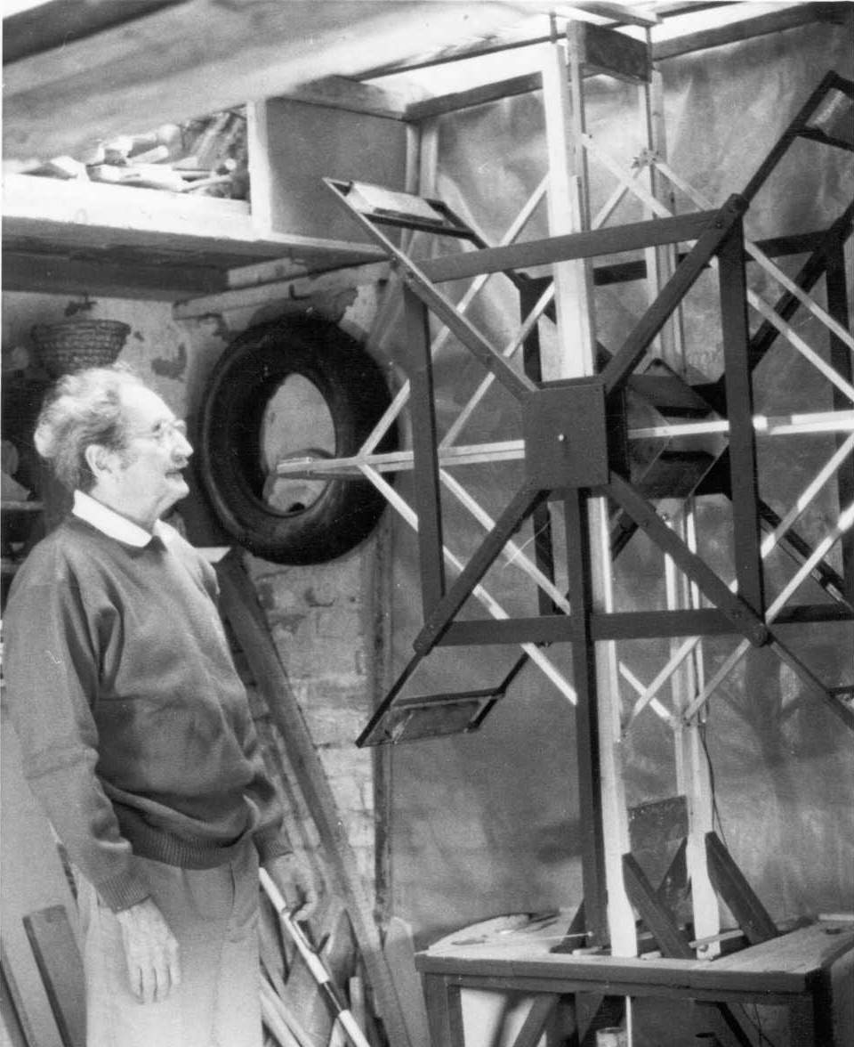

Laszlo Bodonyi (1919-2001) Bodonyi’s instrument for the gravity measure

Investigation of the dynamic gravity
The dynamic gravity effect appears only between moving masses. From the observed features of the new gravitational effect one can conclude, that this new gravity effect may be due to the extra acceleration of the interactive masses causing by the outer forces. That is why the traditional gravity measuring method with torsion balance was not capable to explore this new type of gravity because of its quasi-static feature.
The physical pendulum adjusted to most reachable time period is a ‘perpetual-motion machine’ in consequence of the environment’s noises. The highest components of these noises are reducible with appropriate dampers; we have applied a simple hydraulic damper. The successful measure of dynamic gravity requires a permanent motion of the source mass. It is clear that the source mass motion must be periodic in time.

2. The Quasi-Resonance Measure
For the purpose of detailed investigation of the dynamic gravity we have realized a quasi-resonance measure using the above introduced, relatively big physical pendulum. The experimental setup of our measure is shown in Figure 2:

Figure 2. The setup of the resonance measure of the dynamic gravity
(R = pivot of pendulum; C = mass centre of pendulum)

As it is shown in Figure 2., for the current gravity measurement two source masses have been used. The reliability of the gravitational experiment substantially grows with the simultaneous measuring of two masses. The additional advantage of this two source masses method is the better balancing of the roundtable. But if we measure the two masses separately in time, time-dependent drift errors might occur, for example from the motion of the Moon or from the changes of the pendulum temperature. Nevertheless, it would have been better solution to operate a special air-conditioning system without any air draft in the laboratory.
Figure 2. shows two moving source masses (M = 24 kg, M/2 = 12 kg,) are placed diametrically on a rotating table driven by a small electro-motor through a narrow rubber belt. The rubber belt reduces the vibration noise of the motor-driver. The turntable is made of hard wood in our particular case, but generally any none-magnetic material could be used for this purpose. The turntable and its driver system are placed on the floor, while the hanging of the pendulum is fixed to the ceiling of the laboratory. This solution gives a good isolation against the coupled vibrations of the whole instrument. The fixation of the parts of the measuring system is realized with flexible materials (rubber and plastic spacers). The preliminary control tests proved that there was no measurable mechanical coupling between the turntable and the pendulum. It has also been shown that the automatic system for moving the source mass did not significantly affect the pendulum movement. The radius of the turntable is 0.5 meter; the minimum distance between the source masses and the pendulum lower mass is about 0.2 meter.
In the usual resonance method for gravity measurement, the pendulum frequency is adjusted to the frequency of the periodically rotating source mass. In the beginning of the test period, we tried this normal measuring procedure, but we were not able to reach the wished resonance. Fortunately, in time we have succeeded in discovering the reason for this fault. The relatively quick-rotating source masses cause strong amplitude modulation to the pendulum movement, and simultaneously a strong frequency modulation. From our experience, we have learned that, in the case of a relatively long-period pendulum, the period strongly depends on the amplitude of the pendulum. In our experiment the amplitude and period are approximately proportional to one another, showing the fact that the kinetic energy of the pendulum is almost constant. This situation occurs when the pendulum period is unusually big.
Because of the instability of pendulum frequency, the resonance conditions were not fulfilled. The solution of this problem was to reduce the rotation frequency of the turntable until the gravitational resonance appeared. Away from resonance, pendulum amplitude is less than 3-5 mm, which we qualified as the basic noise of the pendulum. In our most successful measurements, the period of the pendulum was about 72 sec, and the rotation period of the turntable was slowly reduced, encountering the resonance at about 4 x 72 sec = 288 sec period. At that time the pendulum amplitude increased up to 10 mm. From this reason our experimental measurement method could more precisely be called ‘enforced resonance’. The rotating source masses produce modulation of the pendulum amplitude caused by the new gravitational effect. Graph 1. presents the dynamic gravity measure with resonance method in the case of arrangement of the experiment shown in Figure 2.:

Graph 1. Gravity measure with quasi-resonance method.
The physical pendulum amplitude vs. time. The total duration of this measure is 3500 s.

3. Theoretical Investigation of the Dynamic Gravity
The reliable theoretical analysis of the above described gravitational experiment was not an easy task. It was only clear that in the experiment a continuous energy transport realized from the source masses into the physical pendulum. The quasi-resonance experiment was conducted at the end of 1999. Many years have been spent without rely acceptable theoretical model for the describing of our new ‘dynamic’ gravity. We have executed many calculations by checking of different erroneous ideas to reach a physically comforting result. At last we have found the most simple successful math model for dynamic gravity force:

(3.1)

Here B is the ‘dynamic gravity’ constant. The letter B was choice for tribute of Mr. Laszlo Bodonyi Hungarian physicist, who has firstly observed the dynamic gravity. The letter ‘a’ signalizes the acceleration between the gravitationally interactive masses caused by non-gravitational forces. If the outer strange forces vanish (i.e. in the cases of clean gravitational systems), the original Newtonian gravity law becomes valid:

(3.2)

The new, extended gravity law can be written into more precise form, regarding to the both attractive and repulsive features of the experienced dynamic gravity:

(3.3)
where
(3.4)

The vectors r₁ and r₂ are the coordinates of the interacting masses m₁ and m₂, respectively.

4. Simulation of the Quasi-Resonance Experiment
The goal of the computer simulation was to prove the validity of (3.3) force law for the dynamic gravity. We have supposed that the free pendulum movement is nearly harmonic regarding to relative small amplitude of its motion. The magnetic gravity effect acts to the pendulum as an excitation force. From the classical theory of the mechanics, the movement of the pendulum is determined mathematically with an inhomogeneous second order differential equation:
(4.1)

where m* is the effective inertial mass of the pendulum. The damping factor of the pendulum is signalized with λ. The ω is the self-frequency of the physical pendulum, which is about nearly 2π /288s. In optimal situation the pendulum has a sharp resonance-curve and the outer excitation force rigorously affects to the pendulum with the same pendulum frequency. In a real situation this conditions are far not fulfilled. The pendulum behaves as a broadband radio receiver in a certain frequency domain. The two lead masses of the turntable radiate with different dynamic gravitational frequencies which both excite the pendulum. From the measured quasi-stationer pendulum movement (Figure 3.) we can determinate the dominant pendulum frequencies and they intensities with Fast Fourier Transformation (FFT).
In a better simulation model we have replaced the (4.1) simple equation with multi-frequency equations:

(4.2)

where ω_{s} are the obtained dominant frequencies from FFT. In the above expression the equations are independently resolvable for all measured frequencies. The observed pendulum movement can be approximate with linear combination of the (4.2) solutions:

(4.3)

The simulation of the measured pendulum movement with the supposed (3.3) dynamic gravity force law needs the optimal determination of the weight factors c_{s}. From the math simulation of the quasi-resonance gravity measure based on (4.2) formulae was remarkable successful.

5. The Results of Computerized Simulation
In the simulation procedure we have investigated a part of the measured pendulum movement from Graph 1. The selection principle of this part was the best periodicity of the measured pendulum movement (Graph 2.):

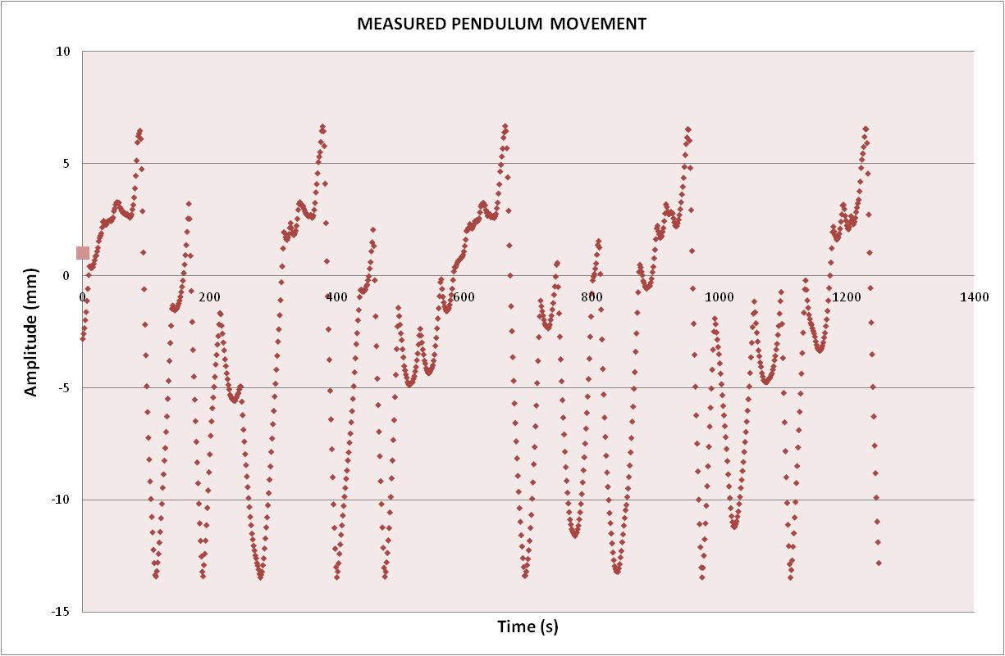

Graph 2. A part of gravity measure with quasi-resonance method.
The physical pendulum amplitude vs. time.

The modeled pendulum movement based on the supposed force expression of the dynamic gravity (3.3) is given in the Graph 3. From the fitting procedure of the simulated pendulum movement we have got that important parameters featured the dynamic gravity:

(5.1)

Unfortunately, these two parameters depend on each other. The independent measure of the damping factor would give not a correct value because it depends on the pendulum amplitude.
Here are the main excitation frequencies and intensities representing of our quasi-resonance experiment (Table 1.):

Table 1. The dominant frequencies and intensities in the pendulum movement (simulation).
Despite all efforts, the experimental pendulum movement has remained strongly disturbed. That is why there was no sense to take consideration the highest frequency components into the model.

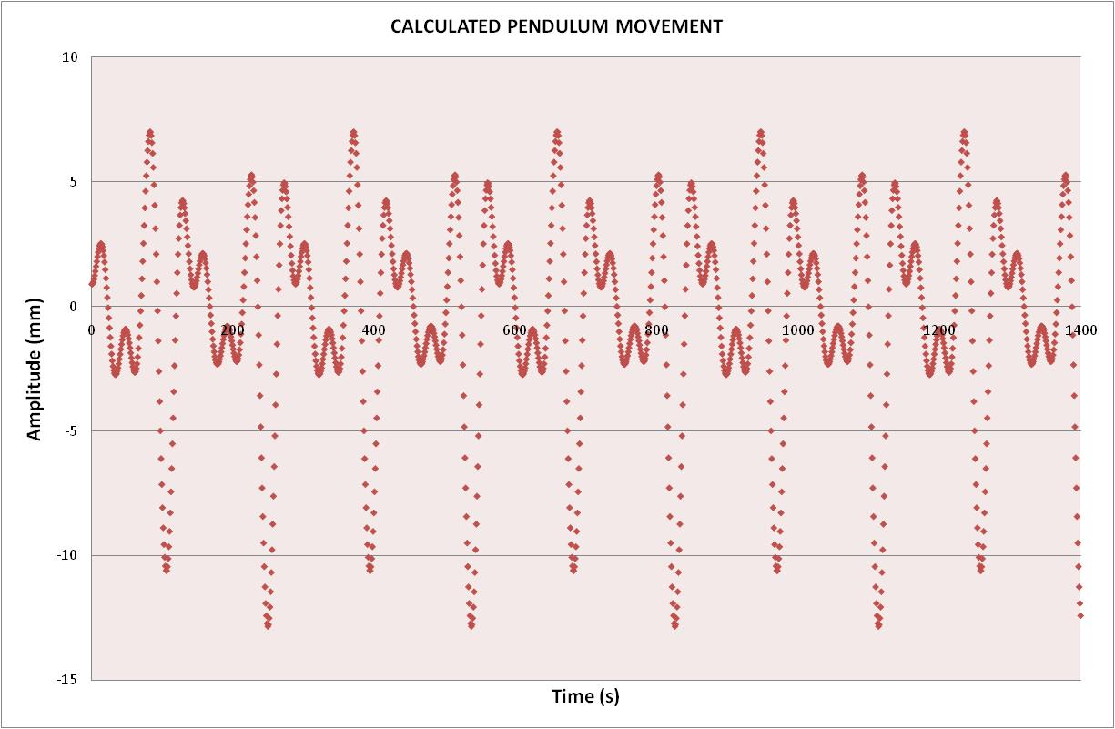

Graph 3. The mathematically simulated part of the gravity measure.
The modeled physical pendulum amplitude vs. time.

6. Remarks and Conclusion
Our last quasi-resonance gravity experiment was conducted in 1999. In the absence of technical and financial background we could not continue the investigations related to ‘dynamic gravity’. In the past years the most important goal was to find the correct theoretical interpretation of our main experiment described in this paper. As it was mention earlier, number of physical model were developed without a deep conviction about them. Our experiment was reported a number of professional journals abroad and also at home, in Hungary. The most common feedback was that we have measured not the gravity but some other side effects (mainly unexplored vibration effects). Nevertheless, we have conducted some control experiment for the reliable exclusion of any side effects. Extremely attention was devoted for the exclusion of electrostatic disturbs with appropriate electrical grounding of the whole instrument. Unfortunately, the physical society regards unbelievable the results of our experiment from different theoretical aspects but nobody has tried to repeat this simple gravitational experiment until this time.
First we have tried to back our experiment to the consequence of Newtonian gravity, and then to a special gravitomagnetic effect. Finally, the experienced very strong gravity constant (B) foiled these ideas. It seems not a good idea to accept a new hypothesis that the gravity has really two forms (weak and strong) in the Nature for the physical science community.
We hope that our final correct statement is that the dynamic gravity is a special behavior of Newtonian gravity. The Newtonian gravity law is valid (by everyday experience) for the closed gravitational systems, when the energy of system is constant and the systems are in an equilibrium state in certain sense. This equilibrium states after a certain time and that we can experience it, for example especially in the Cavendish torsion balance experiment (having very slow movement of the torsion pendulum). Remarkable analogue fact that the nucleons within the nuclei are loosely bound (a closed system, equilibrium state) in contrary with the strong nuclear reactions, when the energy of interactive nuclei are not constant.
In our quasi-resonance experiment a continuous energy exchange realized between the interactive masses. In our relatively long-term experiment our measuring system could not reach the gravitational equilibrium because of the permanent exiting of the physical pendulum. The total energy of this gravitational system periodically changes. We supposed that this is the objective reason of our newly experienced gravitational phenomenon. The exact condition of this dynamic gravity effect is an outer, strong time-dependent force (from a motor-driven turntable) holding far the pendulum from the gravitational equilibrium. The planets of our Solar System constantly interact with each other, but the origin of these forces is only those gravity that caused by themselves. The Sun System is very like in gravitational equilibrium state: the Kepler laws are fulfilled for all of them determining their distances from the Sun and orbital periods. In addition, the Bode-Titius rule probably also shows a special unknown type of the equilibrium state of the whole system. If an outer force (for example a collision with a big asteroid) would have act for any of them, probably significantly stronger effect (dynamic gravity effect) would be appear in our Solar System. Fortunately, we have no such experience for this cosmic scale dynamic gravity catastrophe, but our experiment could give important information about this extraordinary event in a small laboratory.

